Submitted by-Aditya Gautam

Roll No-12

M.sc. 3rd semester

Date of Assignment-03/11/2020

Date of Submission-10/11/2020

**Experiment No -03**

**Topic**- Tracing of Power curve for testing variance of a Normal Population**.**

**Problem** – A random sample of size 16 is drawn from a N(, where  is unknown.Draw the Power curves for testing : against

i) H1:>3 ii) H1: <3 iii) H1:

Given that the size of the test in each of the cases is 

**Theory and Calculation**-

Using Neyman’s pearson fundamental lemma, the critical region is given by-



Here,; , , 













(say)

Where,



**Case 1:**

When , then the C.R. is,



**Case 2:**

When , then the C.R. is,



**(i)**The C.R. for testing : against H1:>3 is given by



where k1 is a constant to be determined such that the size of the C.R. is equal to  ,

i.e., 











To find the value of k1,we use the following R-command :

a = qchisq(0.95,16,0) (0 is the non-centrality parameter)

This gives us the value  26.29623

26.29623=26.296233=78.88869

Thus the C.R. is given by,



Now, the Power of the test is given by,

Power=1-β

=P{Reject H0|H1 is true}











Where, is the distribution function of the chi-square distribution with ‘n’ d.f.

Now to trace the power curve we consider different trial values of and construct the following table using R-Programming.

**Programming in R for case 1**

a = qchisq(0.95,16,0)

a

var = 3

k1 = var*a

k1

sigma1=c(3.1,3.2,3.3,3.4,3.5,3.6,3.7,3.8,3.9,4.0,4.1,4.2,4.3,4.4,4.5,4.6,4.7,4.8,4.9,5.0,5.1,5.2,5.3,5.4,5.5,5.6,5.7,5.8,5.9,6.0)

sigma11 = k1/sigma1

power = mat.or.vec(30,1)

power1 = mat.or.vec(30,1)

for(i in 1:30){

power[i] = pchisq(sigma11[i],16,0)

power1[i] = 1-power[i]}

power1

plot(sigma1,power1)

**TABLE: 1**

|  |  |
| --- | --- |
| **Trial values of  (>3)** | **Power** |
| 4.1 | 0.2563569 |
| 4.2 | 0.2800755 |
| 4.3 | 0.3040172 |
| 4.4 | 0.3280564 |
| 4.5 | 0.3520771 |
| 4.6 | 0.3759738 |
| 4.7 | 0.3996513 |
| 4.8 | 0.4230254 |
| 4.9 | 0.4460222 |
| 5.0 | 0.4685780 |
| 5.1 | 0.4906386 |
| 5.2 | 0.5121589 |
| 5.3 | 0.5331021 |
| 5.4 | 0.5534392 |
| 5.5 | 0.5731480 |
| 5.6 | 0.5922128 |
| 5.7 | 0.6106233 |
| 5.8 | 0.6283744 |
| 5.9 | 0.6454653 |
| 6.0 | 0.6618989 |
| 6.1 | 0.6776815 |
| 6.2 | 0.6928221 |
| 6.3 | 0.7073322 |
| 6.4 | 0.7212251 |
| 6.5 | 0.7345157 |
| 6.6 | 0.7472204 |
| 6.7 | 0.7593562 |
| 6.8 | 0.7709412 |
| 6.9 | 0.7819939 |
| 7.0 | 0.7925329 |

**Power curve for case 1**

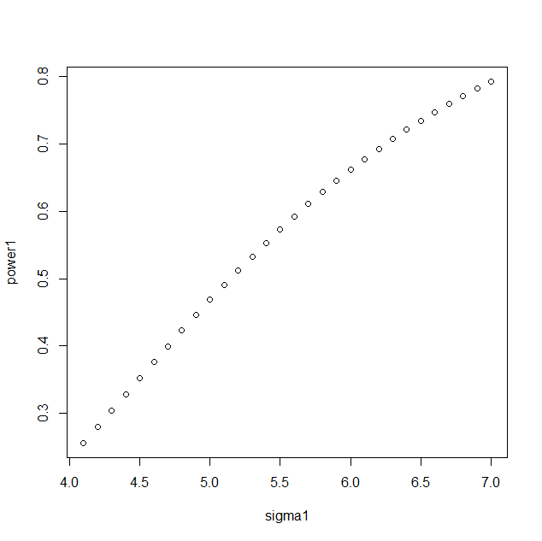

**(ii)**The C.R. for testing : against H1:<3 is given by



where k2 is a constant to be determined such that the size of the C.R. is equal to  ,

i.e., 







To find the value of k2,we use the following R-command :

a = qchisq(0.05,16,0) (0 is the non-centrality parameter)

This gives us the value  7.961646

= 7.9616463=23.884938

Thus the C.R. is given by,



Now, the Power of the test is given by,

Power=1-β

=P{Reject H0|H1 is true}









Where, is the distribution function of the chi-square distribution with ‘n’ d.f.

Now to trace the power curve we consider different trial values of and construct the following table using R-Programming.

**Programming in R for case 2**

a = qchisq(0.05,16,0)

a

var = 3

k1 = var*a

k1

sigma1 = c(2.01,2.02,2.03,2.04,2.05,2.06,2.07,2.08,2.09,2.10,2.11,2.12,2.13,2.14,2.15,2.16,2.17,2.18,2.19,2.20,2.21,2.22,2.23,2.24,2.25,2.26,2.27,2.28,2.29,2.30)

sigma11 = k1/sigma1

power = mat.or.vec(30,1)

for(i in 1:30){

power[i] = pchisq(sigma11[i],16,0)}

power

plot(sigma1,power)

**TABLE: 2**

|  |  |
| --- | --- |
| **Trial values of  (<3)** | **Power** |
| 2.01 | 0.2480098 |
| 2.02 | 0.2440114 |
| 2.03 | 0.2400737 |
| 2.04 | 0.2361961 |
| 2.05 | 0.2323777 |
| 2.06 | 0.2286180 |
| 2.07 | 0.2249163 |
| 2.08 | 0.2212720 |
| 2.09 | 0.2176842 |
| 2.10 | 0.2141525 |
| 2.11 | 0.2106760 |
| 2.12 | 0.2072542 |
| 2.13 | 0.2038862 |
| 2.14 | 0.2005715 |
| 2.15 | 0.1973093 |
| 2.16 | 0.1940989 |
| 2.17 | 0.1909398 |
| 2.18 | 0.1878311 |
| 2.19 | 0.1847723 |
| 2.20 | 0.1817626 |
| 2.21 | 0.1788013 |
| 2.22 | 0.1758879 |
| 2.23 | 0.1730216 |
| 2.24 | 0.1702017 |
| 2.25 | 0.1674277 |
| 2.26 | 0.1646988 |
| 2.27 | 0.1620144 |
| 2.28 | 0.1593739 |
| 2.29 | 0.1567766 |
| 2.30 | 0.1542218 |

**Power curve for case 2**

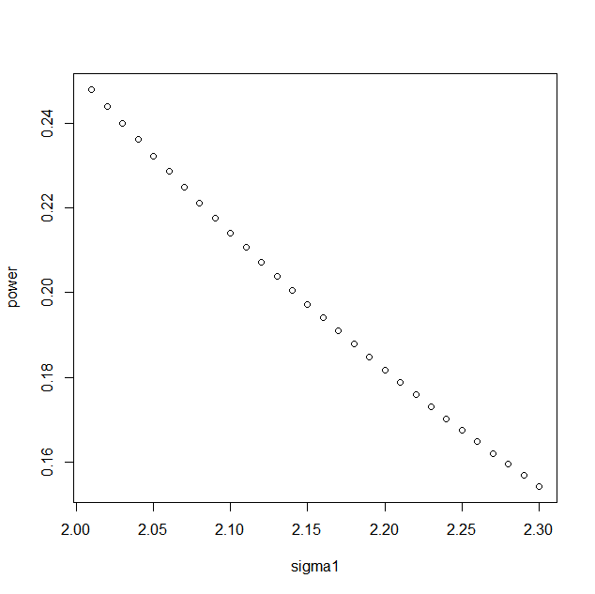

**(iii)**The C.R. for testing : against H1:3 is given by

W3={<k3 or  k4 }

where k3 and k4 are constants to be determined such that,



<k3 or  k4 |H0}=.05



Since, both are mutually exclusive

Assuming that the test is equitailed we have,







To calculate the value of c and d, we use the following R-command :

c = qchisq(0.025,16,0)

var = 3

k3 = var*c

d = qchisq(0.975,16,0)

var = 3

k4 = var*d





Thus the C.R. is given by,

W3={<20.72299or  86.53605}

Now, the Power of the test is given by,

Power

<20.72299or  86.53605|H1 }





Now to trace the power curve we consider different trial values of and construct the following table using R-Programming.

**Programming in R for case 3**

c = qchisq(0.025,16,0)

d = qchisq(0.975,16,0)

var = 3

k3 = var*c

k4 = var*d

k3

k4

sigma1=c(0.9,1,1.1,1.2,1.3,1.4,1.5,1.6,1.7,1.8,1.9,2,2.1,2.3,2.4,2.5,2.6,2.7,2.8,2.9,3.1,3.2,3.3,3.4,3.5,3.6,3.7,3.8,3.9,4.0,4.1,4.2,4.3,4.4,4.5,4.6,4.7,4.8,4.9,5.0)

sigma11 = k3/sigma1

sigma11

sigma22 = k4/sigma1

sigma22

power1 = mat.or.vec(40,1)

for(i in 1:40){

power1[i] = pchisq(sigma11[i],16,0)+(1-pchisq(sigma22[i],16,0))}

power1

plot(sigma1,power1)

**TABLE: 3**

|  |  |
| --- | --- |
| **Trial values of  (3)** | **Power** |
| 0.9 | 0.88694674 |
| 1.1 | 0.81059418 |
| 1.2 | 0.72290398 |
| 1.3 | 0.63161004 |
| 1.4 | 0.54289735 |
| 1.5 | 0.46082501 |
| 1.6 | 0.38753198 |
| 1.7 | 0.32373148 |
| 1.8 | 0.26921596 |
| 1.9 | 0.22326209 |
| 2.0 | 0.18491564 |
| 2.1 | 0.15317390 |
| 2.2 | 0.12709197 |
| 2.3 | 0.08871020 |
| 2.4 | 0.07514532 |
| 2.5 | 0.06469934 |
| 2.6 | 0.05703406 |
| 2.7 | 0.05189660 |
| 2.8 | 0.04909969 |
| 2.9 | 0.04850352 |
| 3.1 | 0.05349975 |
| 3.2 | 0.05892191 |
| 3.3 | 0.06618671 |
| 3.4 | 0.07521037 |
| 3.5 | 0.08590204 |
| 3.6 | 0.09816245 |
| 3.7 | 0.11188378 |
| 3.8 | 0.12695044 |
| 3.9 | 0.14324051 |
| 4.0 | 0.16062749 |
| 4.1 | 0.17898227 |
| 4.2 | 0.19817508 |
| 4.3 | 0.21807731 |
| 4.4 | 0.23856317 |
| 4.5 | 0.25951116 |
| 4.6 | 0.28080528 |
| 4.7 | 0.30233591 |
| 4.8 | 0.32400060 |
| 4.9 | 0.34570450 |
| 5.0 | 0.36736067 |

**power curve for case 3**



**Conclusion-**

Thus we get three different power curves for testing : against

i) H1:>3 ,ii) H1: <3 and iii) H1: respectively at the level of significance .